# Hotel Room Management System



A

Human Computer Interface Course Project Report in partial fulfilment of the degree

## Bachelor of Technology

in

## Computer Science & Engineering

**By**

Krishna Sai Ambati 2103A51301

Sahith Banothu 2103A51304

Sai Prasad Burra 2103A51306

Deepthi Ravula 2103A51336

Under the guidance of

**Mr. K. RAVI CHYTHANYA**

Assistant Professor, School of Computer Science and AI

**Submitted to**

**School of Computer Science and Artificial Intelligence**



1



# DEPARTMENT OF COMPUTER SCIENCE& ENGINEERING

## CERTIFICATE

This is to certify that the **Human Computer Interface - Course Project** Report entitled **“Hotel Room Management System”** is a record of bonafide work carried out by the students krishna sai ambati, sahith banothu, sai prasad burra, deepthi ravula bearing Roll No(s) 2103A51301, 2103A51304, 2103A51306, 2103A51336 during the academic year 2022-23 in partial fulfillment of the award of the degree of ***Bachelor of Technology*** in **Computer Science & Engineering** by the SR University, Warangal.

**Lab In-charge Head of the Department**

|  |  |
| --- | --- |
| **TABLE OF CONTENTS:** |  |
| **Title** | **Page no** |
| **Abstract** | **4** |
| **Objectives** | **5** |
| **Definition of elements used in project** | **6-7** |
| **Design Screens** | **8-11** |
| **Implementation Code** | **12-33** |
| **Result Screens** | **34-39** |
| **Conclusion** | **40** |

# ABSTRACT :

Deluxe is a website developed for the hoteliers and tourists to reserve rooms. In this project, we tried to create a hotel website which will be easy to use by following the various principles of Human Computer Interaction. This Project aims at creating an Hotel Reservation that can be used by customers to reserve hotel rooms. Users can view rooms and facilities. Users can register by giving minimum information and reserve a room. The administrator will know the details of daily reservation done by users. Purpose of making such application is to make people’s work quicker and save time of users and save paper work.

Deluxe undertaken as a project is based on relevant technologies. The main aim of this project is to develop software for Hotels. This project is developed using HTML , CSS and Javascript languages. Creating and managing requirements is a challenge of IT, systems and product development projects or indeed for any activity where you have to manage a contractual relationship. Organization need to effectively define and manage requirements to ensure they are meeting needs of the customer, while proving compliance and staying on the schedule and within budget. The impact of a poorly expressed requirement can bring a business out of compliance or even cause injury or death. Requirements definition and management is an activity that can deliver a high, fast return on investment.

# OBJECTIVE :

The main objective of our website is to build an organic and optimal system of interaction between the hotels and tourists to book a room at any instances.

* Providing surety of availability of rooms at any time.
* Taking minimum information to reserve a room for him/her.
* To reduce reservation time.
* Security to personal information.
* No online payments through website to get rid from cyber attacks.
* Anytime reservation without any payment.

**DEFINITIONS OF ELEMENTS USED IN PROJECT :**

HTML Anchor:

The HTML anchor tag defines a hyperlink that links one page to another page. It can create hyperlink to other web page as well as files, location, or any URL. The "href" attribute is the most important attribute of the HTML a tag. and which links to destination page or URL.

The href attribute is used to define the address of the file to be linked. In other words, it points out the destination page.

### HTML Style:

HTML Style is used to change or add the style on existing HTML elements. There is a default stylefor every HTML element e.g. background color is white, text color is black etc.

The style attribute can by used with any HTML tag. To apply style on HTML tag, you should have the basic knowledge of css properties e.g. color, background-color, text-align, font-family, font-size etc.

The color property is used to define the text color. The background-color property is used to define background color for the HTML tag. The font-family property specifies the font family of the HTML tag.

The font-size property is used to define the text size of the HTML tag. The text-align property isused to define the horizontal text alignment for the HTML element.

### HTML Script:

HTML script tag is used to specify client-side script such as JavaScript. It facilitate you to place a script within your HTML document.

JavaScript is used for image manipulation, form validation, and dynamic content.There can be two usage of HTML script tag:

* to embed script code
* to link script file

The script tag can be used within <body> or <head> tag to embed the scripting code. The script tagcan be used to link external script file by src attribute. It must be used within the <head> tag only.

### HTML Div:

The HTML <div> is used to group the large section of HTML elements together.

We know that every tag has a specific purpose e.g. p tag is used to specify paragraph, <h1> to <h6> tag are used to specify headings but the <div> tag is just like a container unit which is used to encapsulate other page elements and divides the HTML documents into sections.

The div tag is generally used by web developers to group HTML elements together and apply CSS styles to many elements at once. For example: If you wrap a set of paragraph elements into a div element so you can take the advantage of CSS styles and apply font style to all paragraphs at once instead of coding the same style for each paragraph element.

### HTML Button:

The <button> tag is used to create a clickable button within HTML form on your webpage. You can put content like text or image within the <button> </button> tag.

You should always specify the type attribute for a <button> tag. Different browsers use different default type for the button element.

HTML Button tag can be used inside and outside the form.

If you use it inside the form, it works as the submit button. You can also use it as reset button.

If you use it outside the form, you can call JavaScript function on it.

# 

# DESIGN

Home Page:

Explore Page:

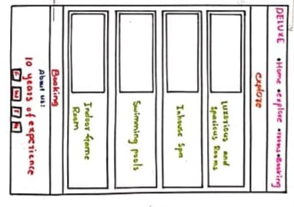

Rooms Page:

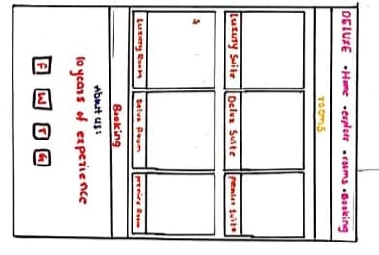

Booking Page:

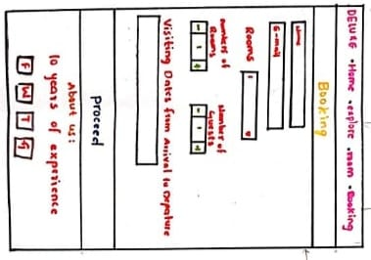

Feedback Page:

# 

# Thankyou Page:

# 

# Admin login Page:

# Reservation details Page:

# IMPLEMENTATION :

HOME PAGE (HTML):

<!DOCTYPE html>

<html lang="en">

<head>

<link rel="stylesheet" href="index.css" />

<title>Home</title>

</head>

<body>

<header>

<h2 class="logo">DELUXE</h2>

<ul class="list">

<li class="item"><a href="index.html" class="links Active">Home</a></li>

<li class="item"><a href="Explore.html" class="links">Explore</a></li>

<li class="item"><a href="Rooms.html" class="links">Rooms</a></li>

<li class="item"><a href="Booking.html" class="links">Booking</a></li>

</ul>

</header>

<div class="center_text">

<div class="waviy">

<span style="--i: 1">W</span>

<span style="--i: 2">E</span>

<span style="--i: 3">L</span>

<span style="--i: 4">C</span>

<span style="--i: 5">O</span>

<span style="--i: 6">M</span>

<span style="--i: 7">E</span>

&nbsp;&nbsp;

<span style="--i: 8">T</span>

<span style="--i: 9">O</span>

&nbsp;&nbsp;

<span style="--i: 10">D</span>

<span style="--i: 11">E</span>

<span style="--i: 12">L</span>

<span style="--i: 13">U</span>

<span style="--i: 14">X</span>

<span style="--i: 15">E</span>

</div>

<div class="body">

<a href="Explore.html" class="btn blue">Explore</a>

</div>

</div>

</body>

</html>

HOME PAGE (CSS):

@import url("https://fonts.googleapis.com/css2?family=Roboto+Condensed&display=swap");

@import url("https://fonts.googleapis.com/css2?family=Roboto:wght@300&display=swap");

@import url("https://fonts.googleapis.com/css2?family=Poppins&display=swap");

@import url("https://fonts.googleapis.com/css2?family=Alfa+Slab+One&display=swap");

* {

padding: 0;

margin: 0;

}

body {

background-image: url(./Images/Hotelbg.jpg);

/* background-color: transparent; */

background-size: cover;

background-repeat: no-repeat;

}

header {

display: flex;

align-items: center;

background-color: transparent;

position: relative;

padding: 20px 20px 0px 20px;

}

.list {

display: flex;

list-style-type: none;

position: absolute;

right: 0;

/* margin-top: 10px; */

margin-right: 40px;

}

.item {

margin-left: 30px;

align-self: center;

font-family: "Roboto Condensed", sans-serif;

color: white;

}

.links {

padding: 10px;

margin-top: 40px;

text-decoration: none;

color: rgb(255, 255, 255);

font-size: 21px;

font-weight: 700;

}

.links:hover {

background-color: black;

border-radius: 15px;

color: whitesmoke;

}

.Active {

text-decoration: none;

background-color: rgb(0, 0, 0);

border-radius: 15px;

color: rgb(255, 247, 247);

}

.logo {

font-size: 40px;

margin-left: 20px;

/* margin-top: 10px; */

font-family: "Poppins", sans-serif;

color: white;

}

.center_text {

display: flex;

flex-direction: column;

text-align: center;

position: relative;

top: 200px;

font-family: Cambria, Cochin, Georgia, Times, "Times New Roman", serif;

}

.title1 {

font-size: 50px;

color: white;

}

.title2 {

margin-top: 10px;

font-size: 25px;

color: whitesmoke;

}

.link {

text-decoration: none;

color: white;

}

.explore {

background-color: black;

width: 100px;

padding: 10px;

border-radius: 15px;

border-style: solid;

color: white;

margin-top: 20px;

font-size: 15px;

cursor: pointer;

transition: 2s;

}

.explore:hover {

background-color: transparent;

}

.waviy {

position: relative;

/* -webkit-box-reflect: below -20px linear-gradient(transparent, rgba(0, 0, 0, 0.2)); */

font-size: 50px;

font-weight: 900;

}

.waviy span {

/* font-family: "Alfa Slab One", cursive; */

position: relative;

display: inline-block;

color: #fff;

text-transform: uppercase;

animation: waviy 9s infinite;

animation-delay: calc(0.5s * var(--i));

}

@keyframes waviy {

0%,

40%,

100% {

transform: translateY(0);

}

20% {

transform: translateY(-20px);

}

}

/* *,

*::before,

*::after {

padding: 0;

margin: 0;

} */

.body {

/* font-family: "Francois One", sans-serif; */

/* background-image: linear-gradient(to right bottom, #fff, #f4edfc); */

box-sizing: border-box;

/* height: 200vh; */

display: flex;

flex-direction: column;

align-items: center;

justify-content: space-evenly;

margin-top: 30px;

}

.btn {

border-radius: 4px;

text-transform: uppercase;

position: relative;

text-decoration: none;

display: flex;

align-items: center;

justify-content: center;

border: 1px solid black;

padding: 1rem 2rem;

/* font-size: 3rem; */

font-weight: 700;

background-color: transparent;

background-size: 300%;

transition: all 0.6s;

}

.blue {

color: rgb(0, 0, 0);

border-radius: 80px;

background-image: linear-gradient(160deg, white 50%, rgb(0, 0, 0) 50%);

}

.btn:hover {

color: #fff;

background-position: 100%;

transform: translateX(0.5rem);

}

.btn:active {

transform: translate(0.5rem, 0.5rem);

box-shadow: 0px 10px 20px -15px rgba(0, 0, 0, 0.75);

}

Explore Page(HTML):

<!DOCTYPE html>

<html lang="en">

<head>

<meta charset="UTF-8" />

<script

src="https://code.jquery.com/jquery-3.2.1.slim.min.js"

integrity="sha384-KJ3o2DKtIkvYIK3UENzmM7KCkRr/rE9/Qpg6aAZGJwFDMVNA/GpGFF93hXpG5KkN"

crossorigin="anonymous"

></script>

<script

src="https://cdn.jsdelivr.net/npm/popper.js@1.12.9/dist/umd/popper.min.js"

integrity="sha384-ApNbgh9B+Y1QKtv3Rn7W3mgPxhU9K/ScQsAP7hUibX39j7fakFPskvXusvfa0b4Q"

crossorigin="anonymous"

></script>

<script

src="https://cdn.jsdelivr.net/npm/bootstrap@4.0.0/dist/js/bootstrap.min.js"

integrity="sha384-JZR6Spejh4U02d8jOt6vLEHfe/JQGiRRSQQxSfFWpi1MquVdAyjUar5+76PVCmYl"

crossorigin="anonymous"

></script>

<link

rel="stylesheet"

href="https://cdn.jsdelivr.net/npm/bootstrap@4.0.0/dist/css/bootstrap.min.css"

integrity="sha384-Gn5384xqQ1aoWXA+058RXPxPg6fy4IWvTNh0E263XmFcJlSAwiGgFAW/dAiS6JXm"

crossorigin="anonymous"

/>

<link rel="stylesheet" href="Explore.css" />

<title>Explore</title>

</head>

<body>

<header>

<h2 class="logo">DELUXE</h2>

<ul class="list">

<li class="item">

<a href="index.html" class="links">Home</a>

</li>

<li class="item">

<a href="Explore.html" class="links Active">Explore</a>

</li>

<li class="item"><a href="Rooms.html" class="links">Rooms</a></li>

<li class="item"><a href="Booking.html" class="links">Booking</a></li>

</ul>

</header>

<!-- <div

id="carouselExampleIndicators"

class="carousel slide sliding"

data-ride="carousel"

>

<ol class="carousel-indicators">

<li

data-target="#carouselExampleIndicators"

data-slide-to="0"

class="active"

></li>

<li data-target="#carouselExampleIndicators" data-slide-to="1"></li>

<li data-target="#carouselExampleIndicators" data-slide-to="2"></li>

</ol>

<div class="carousel-inner">

<div class="carousel-item active">

<img

class="d-block w-100 slides"

src="./Images/swimming_pool.jpg"

alt="First slide"

/>

</div>

<div class="carousel-item">

<img

class="d-block w-100 slides"

src="./Images/game.jpg"

alt="Second slide"

/>

</div>

<div class="carousel-item">

<img

class="d-block w-100 slides"

src="./Images/item1.jpg"

alt="Third slide"

/>

</div>

</div>

<a

class="carousel-control-prev"

href="#carouselExampleIndicators"

role="button"

data-slide="prev"

>

<span class="carousel-control-prev-icon" aria-hidden="true"></span>

<span class="sr-only">Previous</span>

</a>

<a

class="carousel-control-next"

href="#carouselExampleIndicators"

role="button"

data-slide="next"

>

<span class="carousel-control-next-icon" aria-hidden="true"></span>

<span class="sr-only">Next</span>

</a>

</div>

<div class="Explore">

<h2 class="Explore_heading">Explore</h2>

</div>-->

<div class="features">

<div class="box">

<div><img src="./Images/item1.jpg" class="feature" /></div>

<div class="text">

<p class="info">Comfortable and Well Equipped Rooms</p>

</div>

</div>

<div class="box">

<div><img src="./Images/swimming_pool.jpg" class="feature" /></div>

<div class="text">

<p class="info">Luxorious Swimming Pool</p>

</div>

</div>

<div class="box">

<div><img src="./Images/Dine.jpg" class="feature" /></div>

<div class="text">

<p class="info">Dining table</p>

</div>

</div>

</div>

<div class="features">

<div class="box">

<div class="glow"><img src="./Images/game.jpg" class="feature" /></div>

<div class="text">

<p class="info">Indoor Game Room</p>

</div>

</div>

<div class="box">

<div class="glow">

<img src="./Images/environment.jpg" class="feature" />

</div>

<div class="text">

<p class="info">Clean and Tidy Environment</p>

</div>

</div>

<div class="box">

<div class="glow"><img src="./Images/wifi.jpg" class="feature" /></div>

<div class="text">

<p class="info">Free WIFI</p>

</div>

</div>

</div>

<div class="body">

<a href="Rooms.html" class="btn blue">Checkout Rooms</a>

</div>

<div class="footer">

<p class="footer_head">About us</p>

<p class="footer_text">

We are a part of chain of luxury hotels which extends all over the

world. We provide a luxorious stay with various value added and free

services which will make you visit us over and over again.

</p>

<img src="./Images/facebook.png" alt="" class="footer_icons" />

<img src="./Images/instagram.png" alt="" class="footer_icons" />

<img src="./Images/twitter.png" alt="" class="footer_icons" />

</div>

</body>

</html>

Explore Page(CSS):

@import url("https://fonts.googleapis.com/css2?family=Roboto+Condensed&display=swap");

@import url("https://fonts.googleapis.com/css2?family=Roboto:wght@300&display=swap");

@import url("https://fonts.googleapis.com/css2?family=Poppins&display=swap");

@import url("https://fonts.googleapis.com/css2?family=Oswald:wght@600&display=swap");

* {

padding: 0;

margin: 0;

}

body {

background-color: rgb(255, 255, 255);

overflow-x: hidden;

width: 100vw;

font-family: sans-serif;

overflow-x: hidden;

}

header {

display: flex;

width: 100vw;

align-items: center;

background-color: transparent;

position: relative;

margin-bottom: 20px;

margin-top: 10px;

}

.list {

display: flex;

list-style-type: none;

position: absolute;

right: 0;

margin-top: 20px;

margin-right: 10px;

}

.item {

margin-left: 20px;

align-self: center;

font-family: "Roboto Condensed", sans-serif;

}

.links {

padding: 10px;

margin-top: 40px;

text-decoration: none;

color: rgb(0, 0, 0);

font-size: 21px;

font-weight: 700;

}

.links:hover {

text-decoration: none;

background-color: rgb(0, 0, 0);

border-radius: 15px;

color: rgb(255, 255, 255);

}

.Active {

text-decoration: none;

background-color: rgb(0, 0, 0);

border-radius: 15px;

color: rgb(255, 247, 247);

}

.logo {

font-size: 40px;

margin-left: 20px;

margin-top: 10px;

font-family: "Oswald", sans-serif;

color: rgb(0, 0, 0);

}

/* .sliding {

margin: 0px 30px 0px 30px;

border-radius: 10px;

} */

/* .slides {

height: 400px;

border-radius: 10px;

margin-bottom: 40px;

} */

/* .Explore_heading {

text-align: center;

margin: 10px 25px;

padding: 10px;

font-family: "Roboto Condensed", sans-serif;

font-weight: 900;

font-size: 30px;

border-style: double;

border-width: 10px;

border-color: aliceblue;

background-color: black;

color: aliceblue;

} */

.features {

display: flex;

align-items: center;

justify-content: center;

/* margin: 0px 60px 0px 60px; */

text-align: center;

}

.box {

margin: 10px;

transition: 1s;

transition: 0.6s;

}

.box:hover {

border-radius: 6px;

background-color: #000000;

color: white;

}

.feature {

height: 300px;

width: 400px;

/* margin-left: 20px; */

/* border-radius: 10px; */

}

/* .booking {

text-align: center;

}

.rooms {

text-decoration: none;

color: white;

}

.book {

border-radius: 23px;

padding: 12px;

background-color: black;

color: whitesmoke;

font-size: 15px;

margin: 10px 0px 20px 0px;

font-family: "Oswald", sans-serif;

transition: 0.9s;

}

.book:hover {

border-radius: 29px;

border-style: dashed;

background-color: white;

text-decoration: none;

color: black;

} */

.button-center {

text-align: center;

margin: 30px 0px 30px 0px;

}

.a-tag {

text-decoration: none;

background-color: black;

color: rgb(255, 255, 255);

width: 200px;

padding: 18px;

border-radius: 25px;

font-size: 15px;

cursor: pointer;

transition: 0.7s;

}

.a-tag:hover {

text-decoration: none;

border-style: dashed;

background-color: white;

color: #000000;

}

.info {

margin-top: 13px;

font-weight: 600;

font-size: 14px;

font-family: "Roboto Condensed", sans-serif;

}

.body {

/* font-family: "Francois One", sans-serif; */

/* background-image: linear-gradient(to right bottom, #fff, #f4edfc); */

box-sizing: border-box;

/* height: 200vh; */

display: flex;

flex-direction: column;

align-items: center;

justify-content: space-evenly;

margin-top: 25px;

}

.btn {

border-radius: 4px;

text-transform: uppercase;

position: relative;

text-decoration: none;

display: flex;

align-items: center;

justify-content: center;

border: 1px solid black;

padding: 1rem 2rem;

/* font-size: 3rem; */

font-weight: 700;

background-color: transparent;

background-size: 300%;

transition: all 0.6s;

}

.blue {

color: rgb(0, 0, 0);

border-radius: 80px;

background-image: linear-gradient(160deg, white 50%, rgb(0, 0, 0) 50%);

}

.btn:hover {

color: #fff;

background-position: 100%;

transform: translateX(0.5rem);

}

.btn:active {

transform: translate(0.5rem, 0.5rem);

box-shadow: 0px 10px 20px -15px rgba(0, 0, 0, 0.75);

}

.footer {

margin-top: 25px;

background-color: #000000;

color: whitesmoke;

/* height: 150px; */

/* width: 100vw; */

text-align: center;

padding: 10px 140px;

font-weight: lighter;

}

.footer_head {

color: white;

font-weight: bold;

font-size: 20px;

margin-bottom: 15px;

}

.footer_text {

margin-bottom: 16px;

}

.footer_icons {

margin: 10px;

height: 50px;

}

.footer_icons:hover {

margin: 8px;

height: 54px;

}

Rooms Page(HTML):

<!DOCTYPE html>

<html lang="en">

<head>

<meta charset="UTF-8" />

<meta http-equiv="X-UA-Compatible" content="IE=edge" />

<meta name="viewport" content="width=device-width, initial-scale=1.0" />

<link rel="stylesheet" href="Rooms.css" />

<title>Rooms</title>

</head>

<body>

<header>

<h2 class="logo">DELUXE</h2>

<ul class="list">

<li class="item">

<a href="index.html" class="links">Home</a>

</li>

<li class="item"><a href="Explore.html" class="links">Explore</a></li>

<li class="item">

<a href="Rooms.html" class="links Active">Rooms</a>

</li>

<li class="item"><a href="Booking.html" class="links">Booking</a></li>

</ul>

</header>

<div class="container">

<div class="types">

<div class="box">

<div class="imgBox">

<img src="./Images/single_room.jpg" />

</div>

<div class="content">

<h2>Single Room</h2>

<p>

Cost : Rs 836/-<br />

Free WIFI

</p>

</div>

</div>

<div class="box">

<div class="imgBox">

<img src="./Images/single_room_permimum.jpg" />

</div>

<div class="content">

<h2>Single Premium Room</h2>

<p>

Cost : Rs 1018/-<br />

Express laundry<br />

Complementary Liquor<br />

Free WIFI

</p>

</div>

</div>

<div class="box">

<div class="imgBox">

<img src="./Images/single_room_luxury.jpg" />

</div>

<div class="content">

<h2>Single Luxury Room</h2>

<p>

Cost : Rs 1302/-<br />

Twice Daily Maid Service<br />

Fully In-Room Cocktail Station<br />

Free WIFI

</p>

</div>

</div>

</div>

<div class="types">

<div class="box">

<div class="imgBox">

<img src="./Images/double_room.jpg" />

</div>

<div class="content">

<h2>Double Room</h2>

<p>

Cost : Rs 2007/-<br />

complementary liquor<br />

free WIFI

</p>

</div>

</div>

<div class="box">

<div class="imgBox">

<img src="./Images/double_room_premimum.jpg" />

</div>

<div class="content">

<h2>Double Premium Room</h2>

<p>

Cost : Rs 2403/-<br />

Express laundry<br />

Complementary Liquor<br />

Free WIFI

</p>

</div>

</div>

<div class="box">

<div class="imgBox">

<img src="./Images/double_room_luxury.jpg" />

</div>

<div class="content">

<h2>Double Luxury Room</h2>

<p>

Cost : Rs 3028/-<br />

Twice Daily Maid Service<br />

Fully In-Room Cocktail Station<br />

Free WIFI

</p>

</div>

</div>

</div>

</div>

<div class="body">

<a href="Booking.html" class="btn blue">Make Reservation</a>

</div>

<div class="footer">

<p class="footer_head">About us</p>

<p class="footer_text">

We are a part of chain of luxury hotels which extends all over the

world. We provide a luxorious stay with various value added and free

services which will make you visit us over and over again.

</p>

<img src="./Images/facebook.png" alt="" class="footer_icons" />

<img src="./Images/instagram.png" alt="" class="footer_icons" />

<img src="./Images/twitter.png" alt="" class="footer_icons" />

</div>

</body>

</html>

Rooms Page(CSS):

@import url("https://fonts.googleapis.com/css2?family=Roboto+Condensed&display=swap");

@import url("https://fonts.googleapis.com/css2?family=Roboto:wght@300&display=swap");

@import url("https://fonts.googleapis.com/css2?family=Poppins&display=swap");

@import url("https://fonts.googleapis.com/css2?family=Oswald:wght@600&display=swap");

* {

padding: 0;

margin: 0;

}

body {

background-color: rgb(255, 255, 255);

overflow-x: hidden;

width: 100vw;

font-family: sans-serif;

}

header {

display: flex;

width: 100vw;

align-items: center;

background-color: transparent;

position: relative;

margin-bottom: 20px;

}

.list {

display: flex;

list-style-type: none;

position: absolute;

right: 0;

margin-top: 20px;

margin-right: 20px;

}

.item {

margin-left: 20px;

align-self: center;

font-family: "Roboto Condensed", sans-serif;

}

.links {

padding: 10px;

margin-top: 40px;

text-decoration: none;

color: rgb(0, 0, 0);

font-size: 21px;

font-weight: 700;

}

.links:hover {

text-decoration: none;

background-color: rgb(0, 0, 0);

border-radius: 15px;

color: rgb(255, 255, 255);

}

.Active {

text-decoration: none;

background-color: rgb(0, 0, 0);

border-radius: 15px;

color: rgb(255, 247, 247);

}

.logo {

font-size: 40px;

margin-left: 20px;

margin-top: 10px;

font-family: "Oswald", sans-serif;

color: rgb(0, 0, 0);

}

/* .head {

text-align: center;

font-size: 30px;

font-family: "Oswald", sans-serif;

margin: 0px 560px 10px 560px;

padding: 7px;

border-style: solid;

background-color: black;

color: rgb(0, 0, 0);

border-radius: 20px;

} */

.types_of_rooms {

text-align: center;

}

.types {

display: flex;

align-items: center;

justify-content: center;

}

.type {

margin: 0px 10px 0px 10px;

}

.room {

height: 300px;

width: 400px;

}

.footer {

margin-top: 25px;

background-color: #000000;

color: whitesmoke;

/* height: 150px; */

/* width: 100vw; */

text-align: center;

padding: 10px 140px;

font-weight: lighter;

}

.footer_head {

color: white;

font-weight: bold;

font-size: 20px;

margin-bottom: 15px;

}

.footer_text {

margin-bottom: 16px;

}

.footer_icons {

margin: 10px;

height: 50px;

}

.footer_icons:hover {

margin: 8px;

height: 54px;

}

.booking {

text-align: center;

}

.book {

border-radius: 19px;

padding: 15px;

background-color: black;

color: whitesmoke;

font-size: 18px;

margin: 20px 0px 20px 0px;

transition: 0.9s;

}

.book:hover {

border-radius: 29px;

border-style: dashed;

background-color: white;

color: black;

}

.container {

position: relative;

/* width: 1200px;

height: 600px; */

/* margin: 80px auto 0; */

}

.container .box {

position: relative;

width: 400px;

height: 250px;

/* width: calc(400px - 60px); */

/* height: calc(300px - 30px); */

background: #000;

float: left;

margin: 15px;

box-sizing: border-box;

overflow: hidden;

box-shadow: 0 5px 10px rgba(0, 0, 0, 0.8);

}

.container .box:before {

content: "";

position: absolute;

top: 10px;

left: 10px;

right: 10px;

bottom: 10px;

border-top: 1px solid #fff;

border-bottom: 1px solid #fff;

box-sizing: border-box;

transition: 0.5s;

transform: scaleX(0);

opacity: 0;

}

.container .box:hover:before {

transform: scaleX(1);

opacity: 1;

}

.container .box:after {

content: "";

position: absolute;

top: 10px;

left: 10px;

right: 10px;

bottom: 10px;

border-left: 1px solid #fff;

border-right: 1px solid #fff;

box-sizing: border-box;

transition: 0.5s;

transform: scaleY(0);

opacity: 0;

}

.container .box:hover:after {

transform: scaleY(1);

opacity: 1;

}

.container .box .imgBox {

position: relative;

}

.container .box .imgBox img {

width: 100%;

transition: 0.5s;

}

.container .box:hover .imgBox img {

opacity: 0.2;

transform: scale(1.2);

}

.container .box .content {

position: absolute;

width: 100%;

top: 50%;

transform: translateY(-50%);

z-index: 2;

padding: 20px;

box-sizing: border-box;

text-align: center;

}

.container .box .content h2 {

margin: 0 0 10px;

padding: 0;

color: #fff;

transition: 0.5s;

transform: translateY(-50px);

opacity: 0;

visibility: hidden;

}

.container .box .content p {

margin: 0;

padding: 0;

color: #fff;

transform: translateY(50px);

opacity: 0;

visibility: hidden;

}

.container .box:hover .content h2,

.container .box:hover .content P {

opacity: 1;

visibility: visible;

transform: translateY(0px);

}

.body {

/* font-family: "Francois One", sans-serif; */

/* background-image: linear-gradient(to right bottom, #fff, #f4edfc); */

box-sizing: border-box;

/* height: 200vh; */

display: flex;

flex-direction: column;

align-items: center;

justify-content: space-evenly;

margin-top: 25px;

}

.btn {

border-radius: 4px;

text-transform: uppercase;

position: relative;

text-decoration: none;

display: flex;

align-items: center;

justify-content: center;

border: 1px solid black;

padding: 1rem 2rem;

/* font-size: 3rem; */

font-weight: 700;

background-color: transparent;

background-size: 300%;

transition: all 0.6s;

}

.blue {

color: rgb(0, 0, 0);

border-radius: 80px;

background-image: linear-gradient(160deg, white 50%, rgb(0, 0, 0) 50%);

}

.btn:hover {

color: #fff;

background-position: 100%;

transform: translateX(0.5rem);

}

.btn:active {

transform: translate(0.5rem, 0.5rem);

box-shadow: 0px 10px 20px -15px rgba(0, 0, 0, 0.75);

}

Booking Page(HTML):

<!DOCTYPE html>

<html lang="en">

<head>

<meta charset="UTF-8" />

<meta http-equiv="X-UA-Compatible" content="IE=edge" />

<meta name="viewport" content="width=device-width, initial-scale=1.0" />

<link rel="stylesheet" href="Booking.css" />

<script

type="text/javascript"

src="https://ajax.googleapis.com/ajax/libs/jquery/3.2.1/jquery.min.js"

></script>

<script type="text/javascript" src="dist/pickmeup.min.js"></script>

<script type="text/javascript" src="dist/handleCounter.js"></script>

<link rel="stylesheet" type="text/css" href="css/pickmeup.css" />

<link rel="stylesheet" type="text/css" href="css/handle-counter.min.css" />

<link rel="stylesheet" type="text/css" href="css/main.css" />

<link

href="https://fonts.googleapis.com/css?family=Open+Sans"

rel="stylesheet"

/>

<script type="text/javascript" src="dist/jquery.scrollUp.js"></script>

<script type="text/javascript" src="dist/demo.js"></script>

<title>Booking</title>

</head>

<body>

<header>

<h2 class="logo">DELUXE</h2>

<ul class="list">

<li class="item">

<a href="index.html" class="links">Home</a>

</li>

<li class="item"><a href="Explore.html" class="links">Explore</a></li>

<li class="item">

<a href="Rooms.html" class="links">Rooms</a>

</li>

<li class="item"><a href="" class="links Active">Booking</a></li>

</ul>

</header>

<section class="tm-booking">

<h2 class="hd">BOOKING</h2>

<a href="Admin_login.html" class="login">Login</a>

<form>

<div class="tm-form1">

<input type="text" name="name" placeholder="Name" required />

<input type="email" name="email" placeholder="E-mail" required />

<label for="rooms" id="inlinelable">Room</label>

<select name="Rooms" id="rooms">

<option value="luxurys">Luxury Suite</option>

<option value="deluxs">Delux Suite</option>

<option value="premiers">Premier Suite</option>

<option value="Luxuryr">Luxury Room</option>

<option value="deluxs">Delux Room</option>

<option value="premierr">Premier Room</option>

</select>

<div class="tm-num1" id="handleCounter1">

<label for="number1">Number of Rooms</label><br />

<button type="button" class="counter-minus btn btn-primary">

-

</button>

<input type="text" name="number1" id="number1" value="1" />

<button type="button" class="counter-plus btn btn-primary">

+

</button>

</div>

<div class="tm-num2" id="handleCounter2">

<label for="number2">Number of Guests</label><br />

<button type="button" class="counter-minus btn btn-primary">

-

</button>

<input type="text" name="number2" id="number2" value="1" />

<button type="button" class="counter-plus btn btn-primary">

+

</button>

</div>

</div>

<!-- <div class="vertical-line"></div> -->

<div class="tm-form2">

<div class="tm-cl">

<label for="date1" class="arrival"

>Visiting Dates from Arrival to Departure</label

>

<input type="text" name="date1" class="range" readonly="readonly" />

<header class="header">

<div class="banner">

<a href="Feedback.html" class="butn butn__new"

><span>BOOK</span></a

>

</div>

</header>

</div>

</div>

</form>

</section>

<div class="footer">

<p class="footer_head">About us</p>

<p class="footer_text">

We are a part of chain of luxury hotels which extends all over the

world. We provide a luxorious stay with various value added and free

services which will make you visit us over and over again.

</p>

<img src="./Images/facebook.png" alt="" class="footer_icons" />

<img src="./Images/instagram.png" alt="" class="footer_icons" />

<img src="./Images/twitter.png" alt="" class="footer_icons" />

</div>

</body>

</html>

# RESULT SCREENS:

Home page:

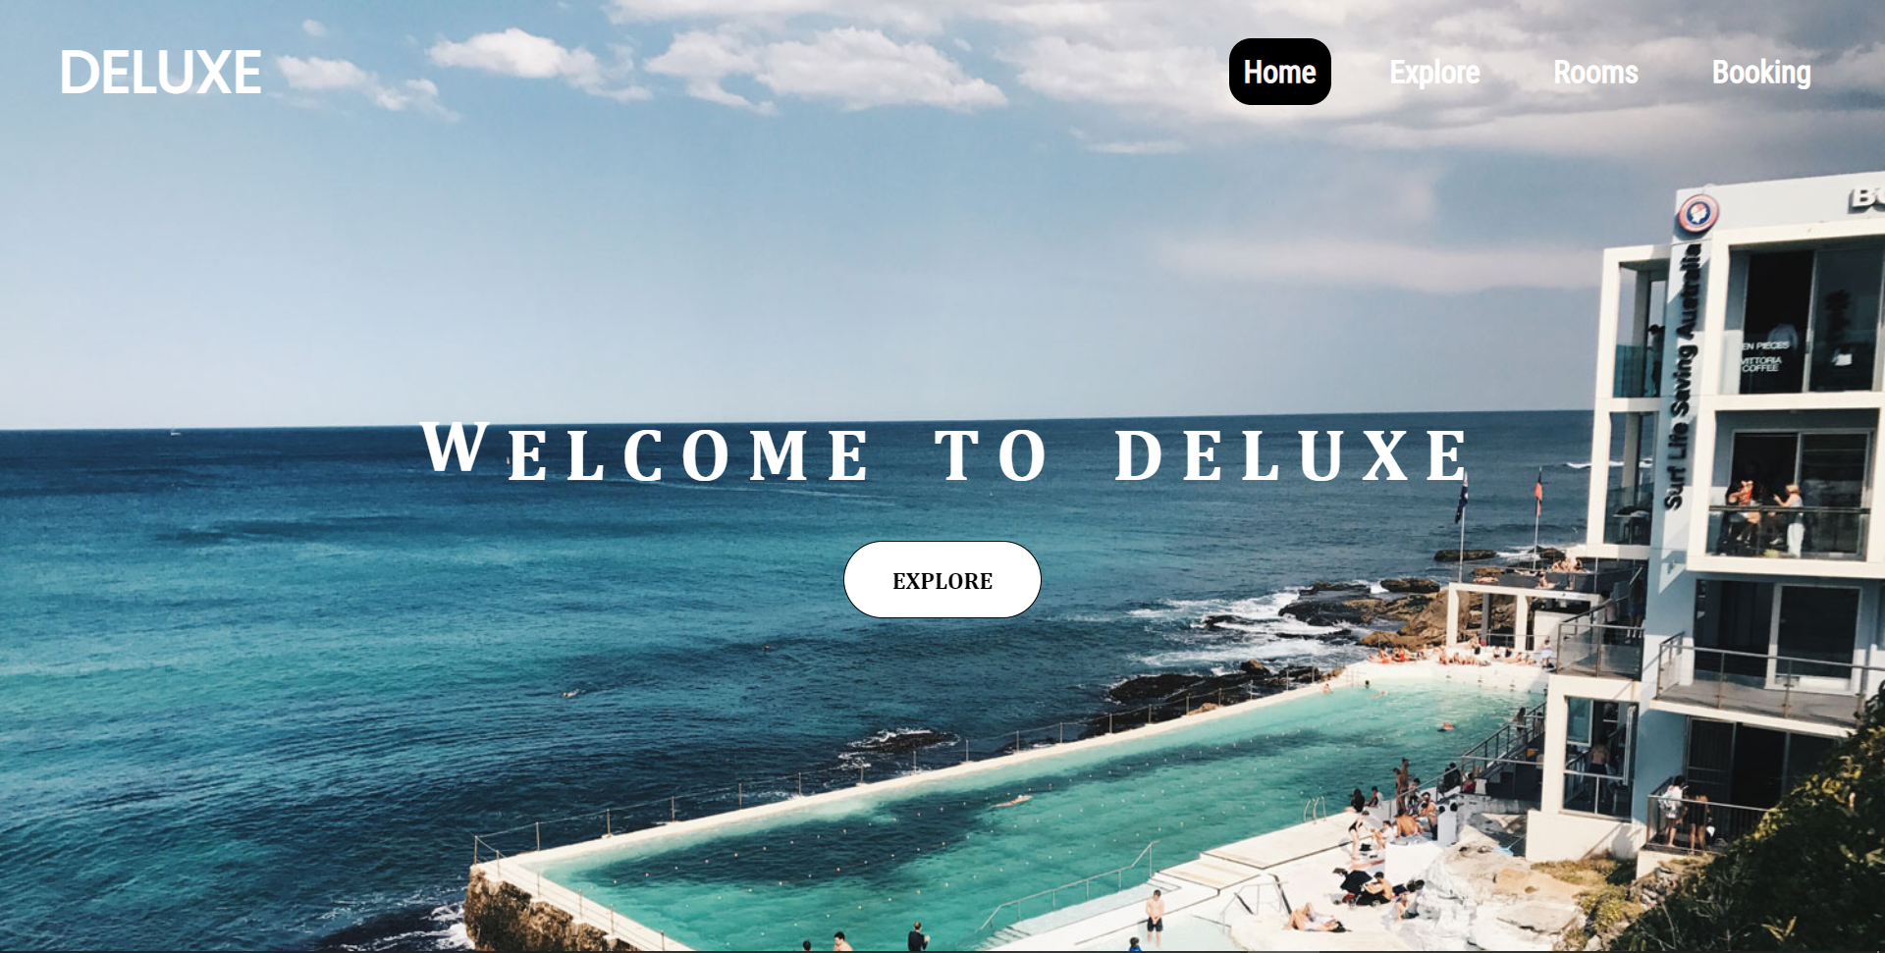

Explore page:

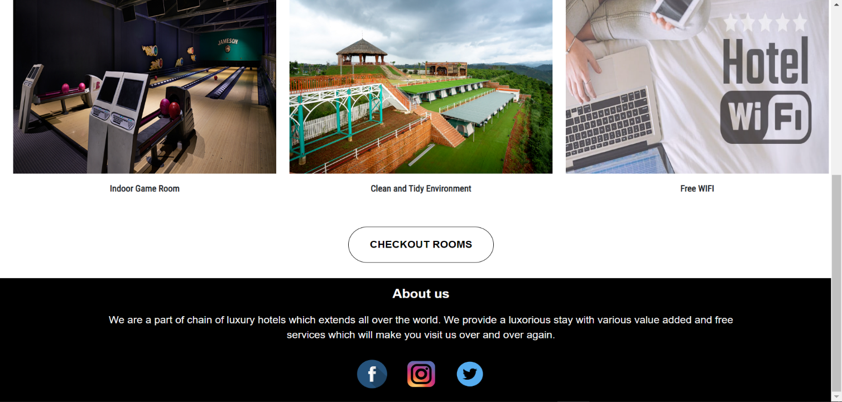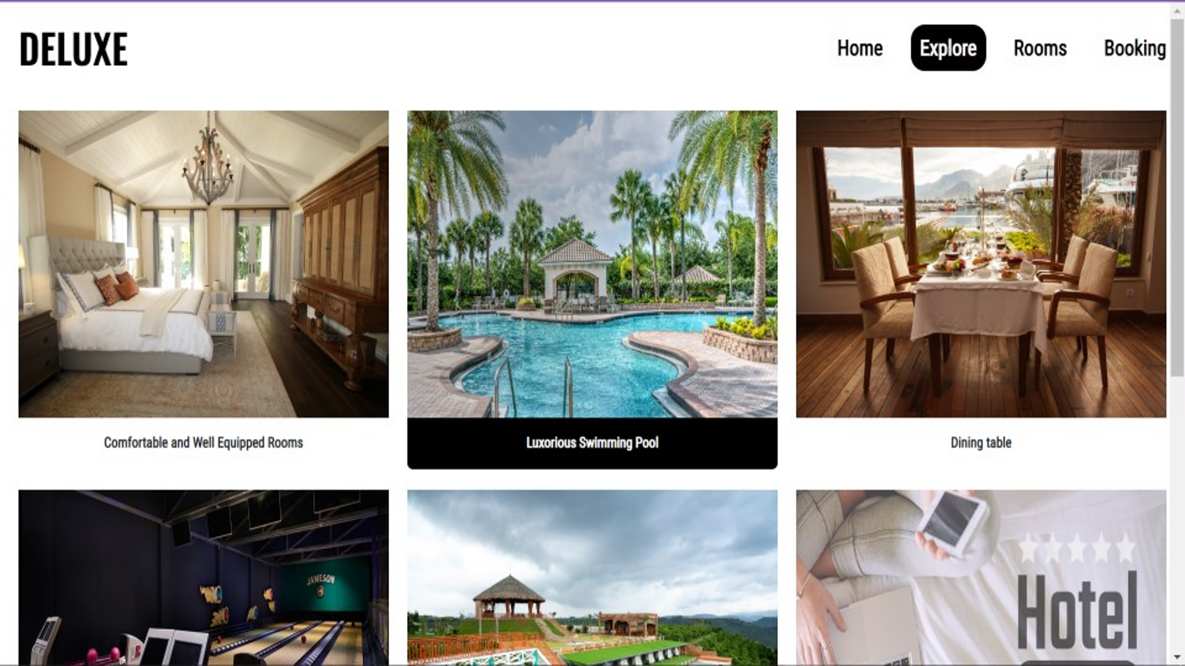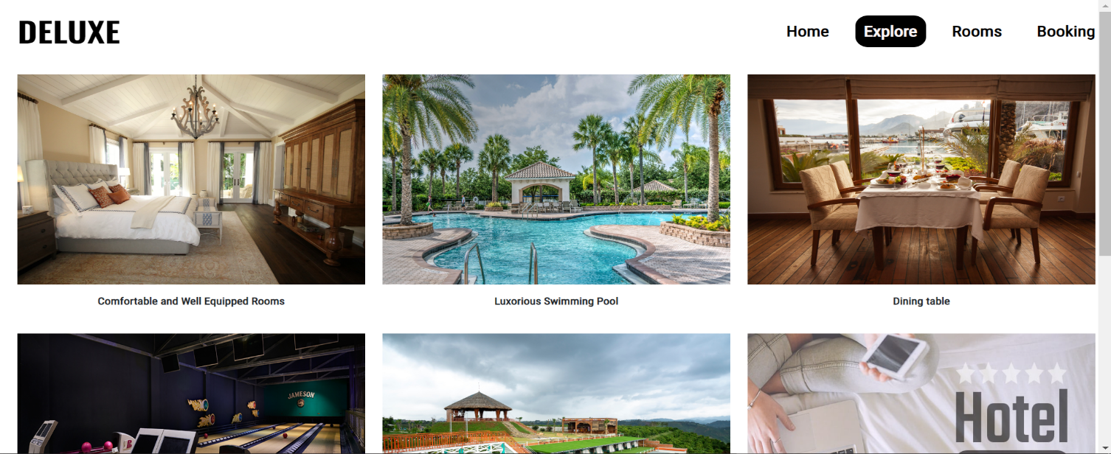

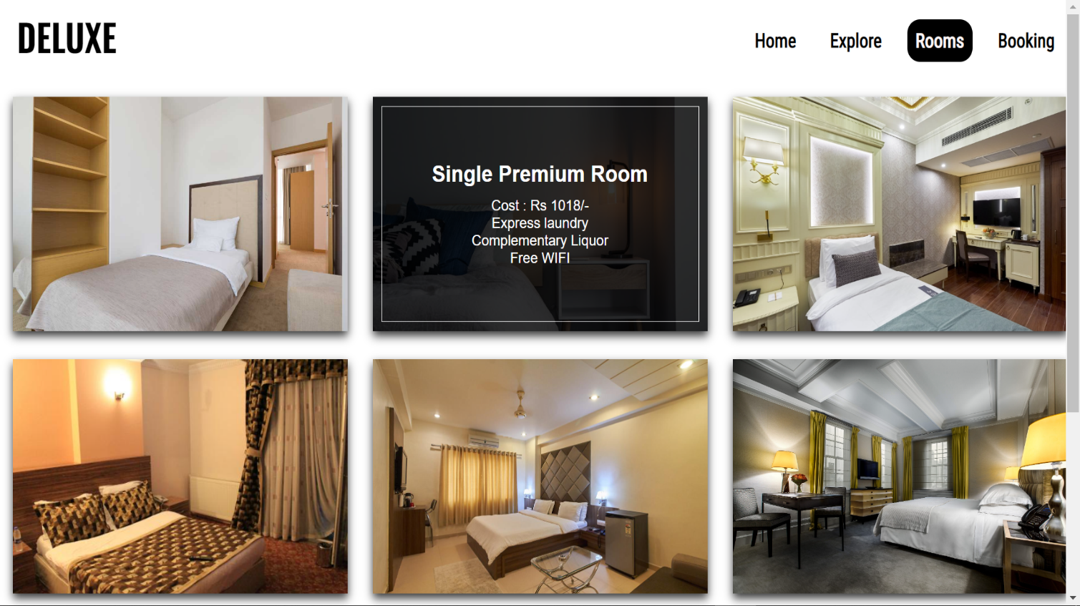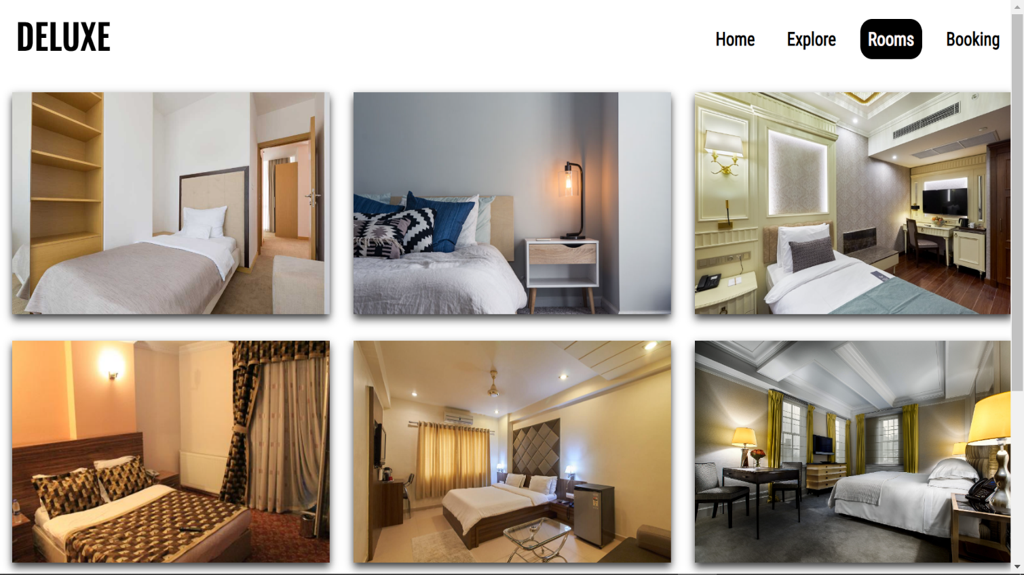 Rooms page:

Booking page: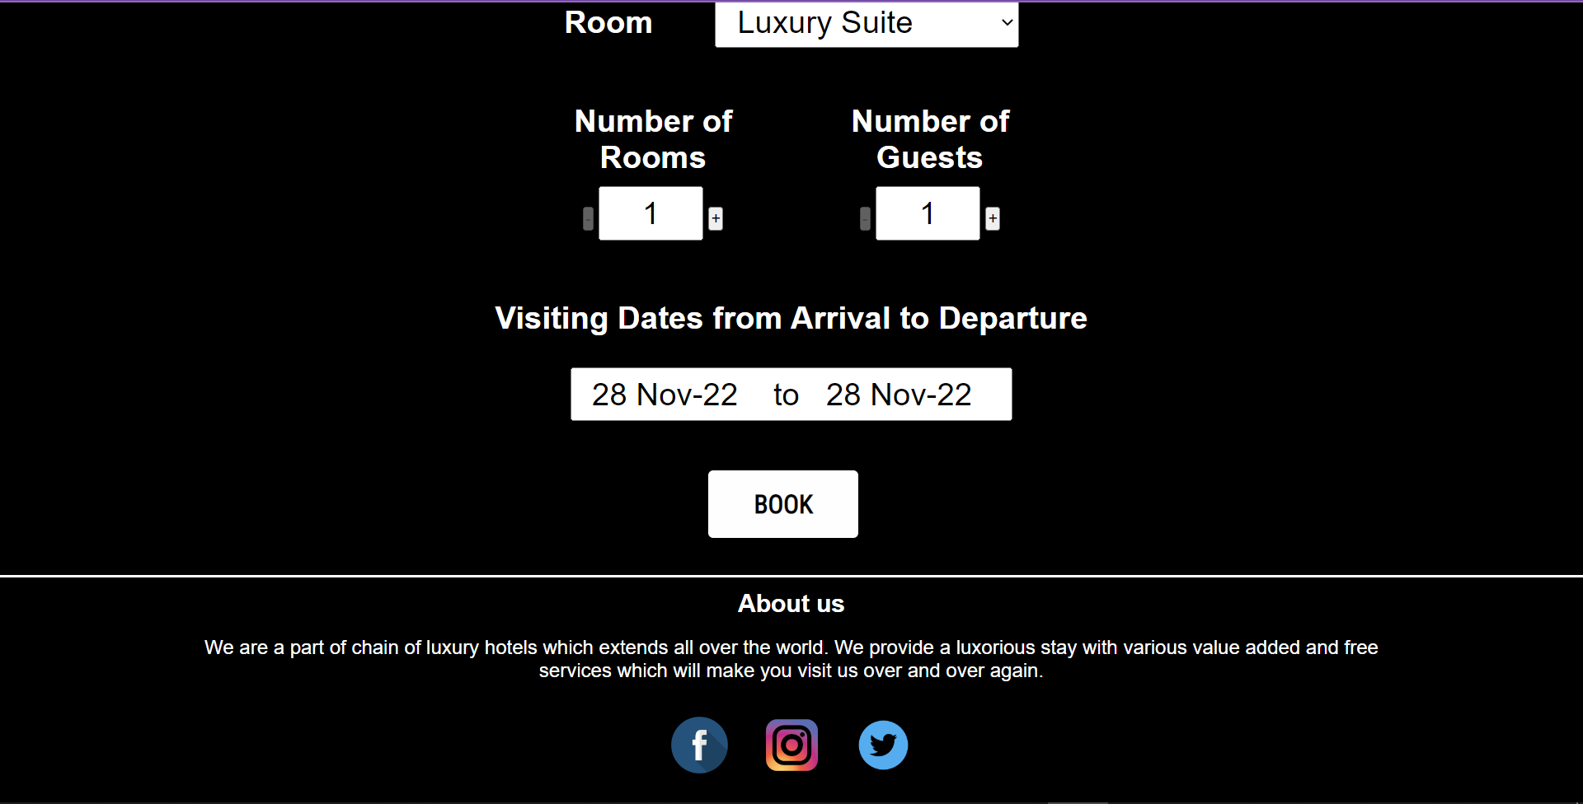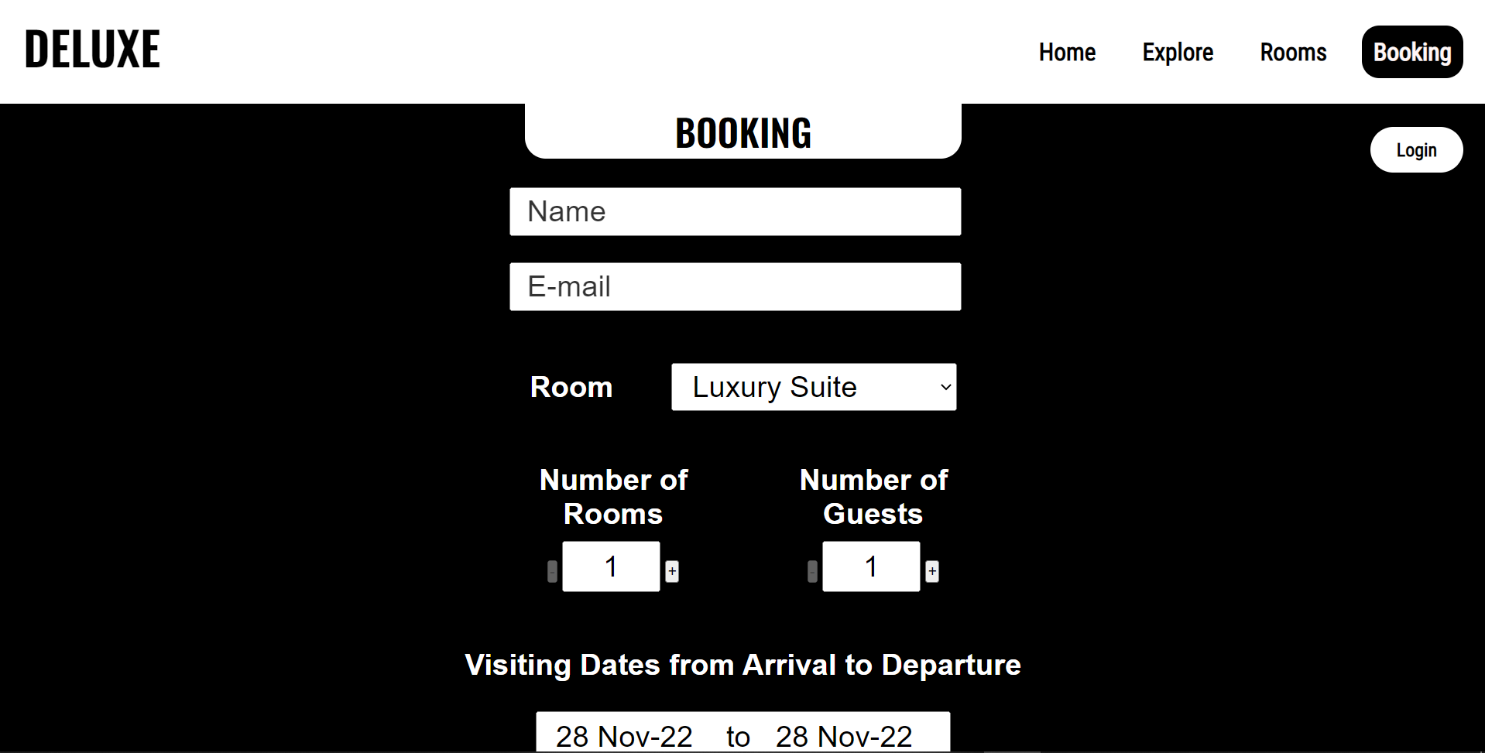

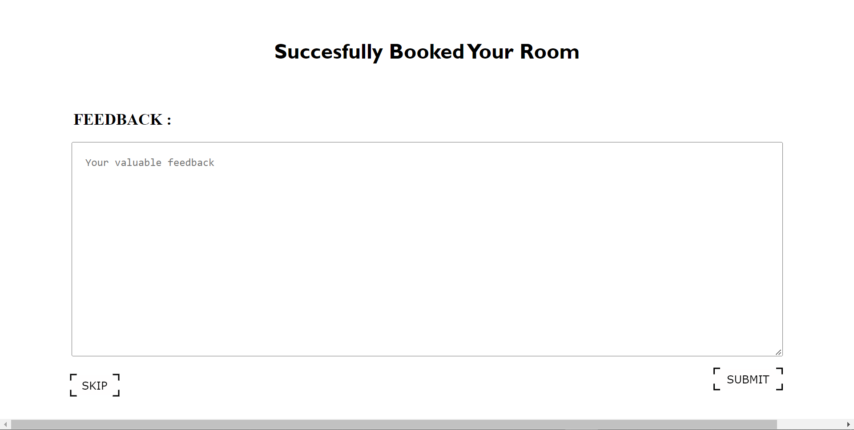 Feedback page:

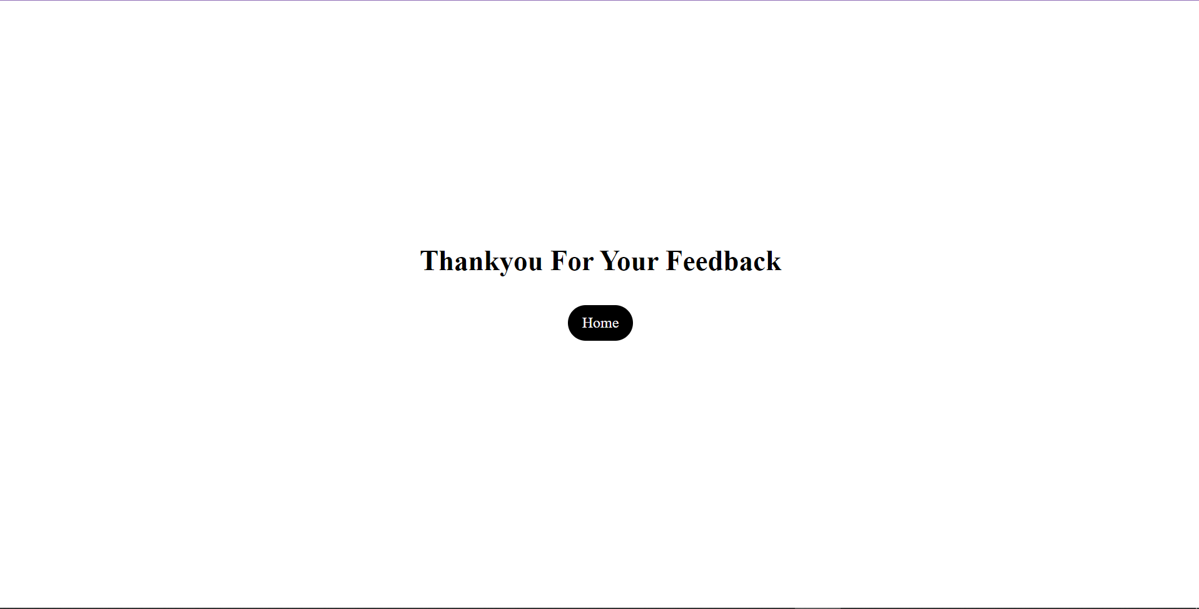 Conclude page:

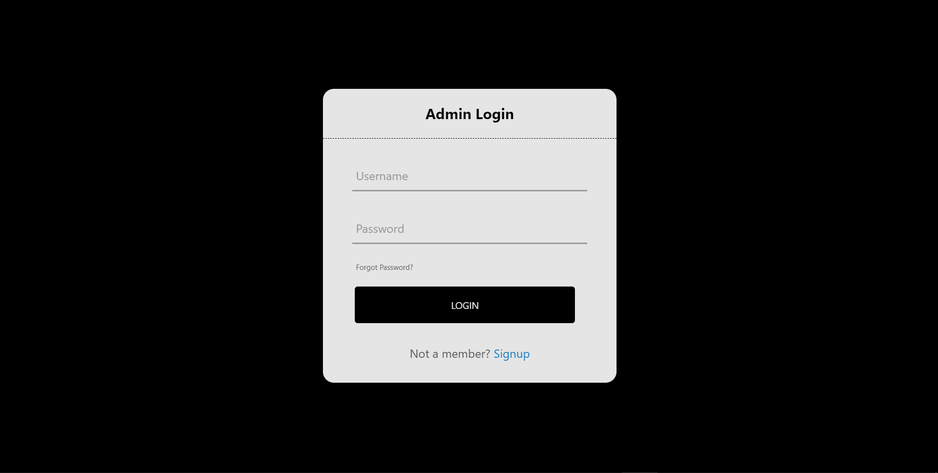 Admin page:

Reservation details page: (Admin side):

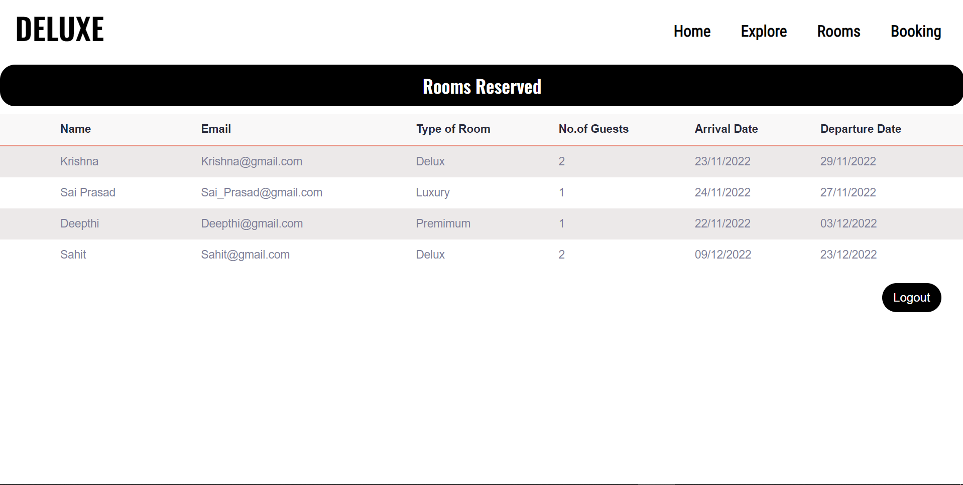

**Conclusion:**

The conclusion of this project is A Hotel management system is a computerized management system. This system keeps the records of hardware assets besides software of this organization. The proposed system will keep a track of Workers, Recidents, Accounts and generation of report regarding the present status. This project has GUI based software that will help in storing, updating and retrieving the information through various user-friendly menu-driven modules.The project “Hotel Management System” is aimed to develop to maintain the day-to-day state of admission/Vacation of Residents, List of Workers , payment details etc. Main objective of this project is to provide solution for hotel to manage most there work using computerized process. This software application will help admin to handle customers information, room allocation details, payment details, billing information.etc. Detailed explanation about modules and design are provided in project documentation. The existing system is a manually maintained system. All the Hotel records are to be maintained for the details of each customers, Fee details, Room Allocation , Attendance etc. All these details are entered and retrieved manually,because of this there are many disadvantages like Time Consuming ,updating process, inaccuracy of data.For avoiding this we introduced or proposed a new system in proposed system the computerized version of the existing system. provides easy and quick access over the data.